**Big Data Programming**

**CSEE5590-0004/490-0004**

**Lab 1 Report**

Team : 6

Chandrasekhar Pentakota (class ID : 9)

Mustafa Bilal (class ID : 15)

**Links :**

<https://github.com/chanduhub/BigDataProgramming/wiki>

https://youtu.be/jfL-AO55erg

**Task 1**

**Objective :** To find Facebook common friends using Map Reduce framework on Apache Hadoop and store the results to a file for easy lookup.

**Feautures :** This model can work on huge amounts of data of facebook profiles and find the mutual friends between the users.

**Steps :**

**Input –**

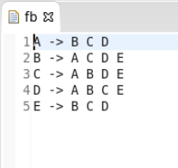

**Output –**

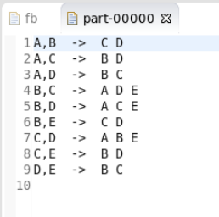

Here in input left side to arrow are the users and right side ones are his friends and are bidirectional that means if A is a friend of B then B is a friend of A. And in output file, we can see the mutual friends of any two users.

The workflow of program

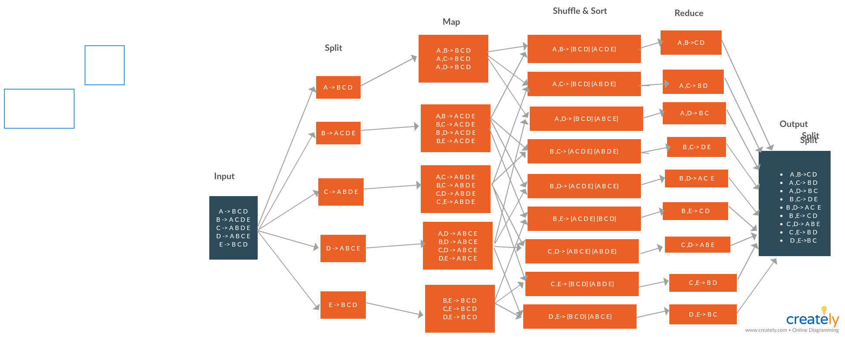

**Mapper :**

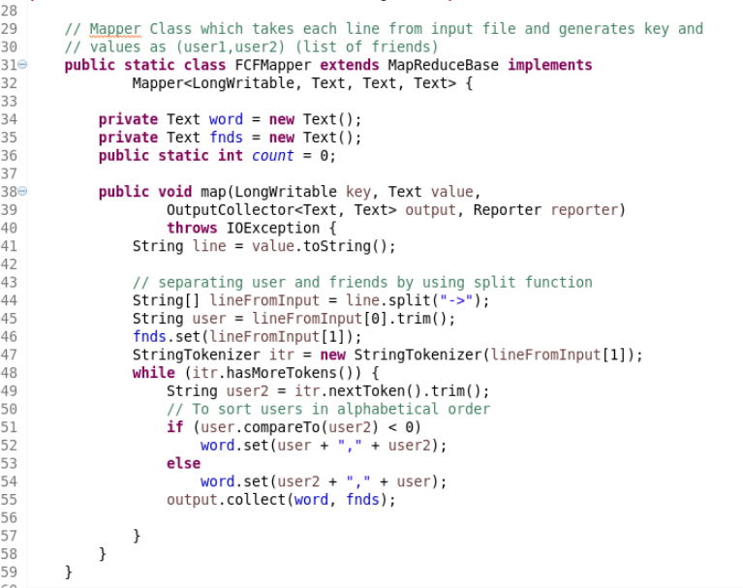

Here FCFMapper gets input as byte offset as key and each line(A-> B C D) as value. Each friend from the value is combined with the user and sorted by using if else condition, the output from the mapper will be in the form of two users as key and list of friends as value.

**Reducer :**

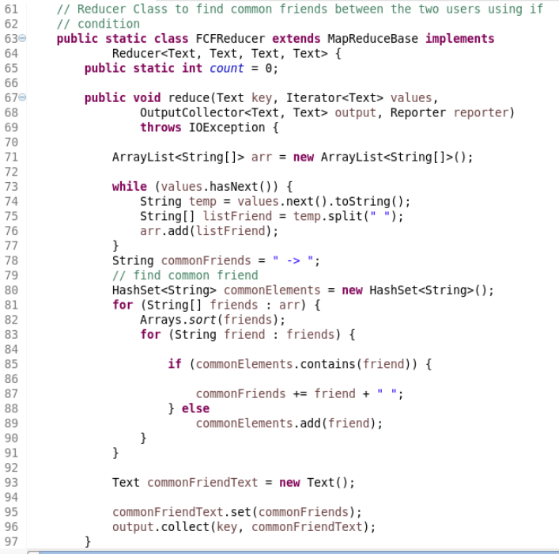

Similar keys from the mapper will go to one reducer, and the condition is reducer to check similar friends from the two users and send it as output value. The result outout from the reducer is two users and their common friends.

**Driver program :**

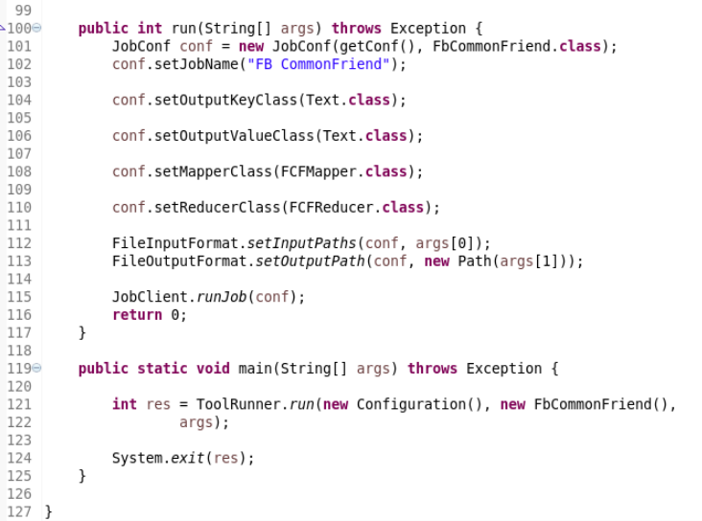

The driver program takes input and output folders as arguments and

Writes output to the file in output directory.

The log files generated while execution are

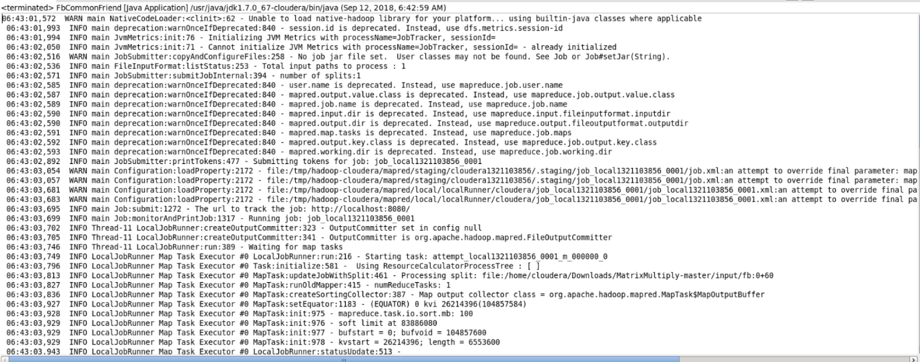

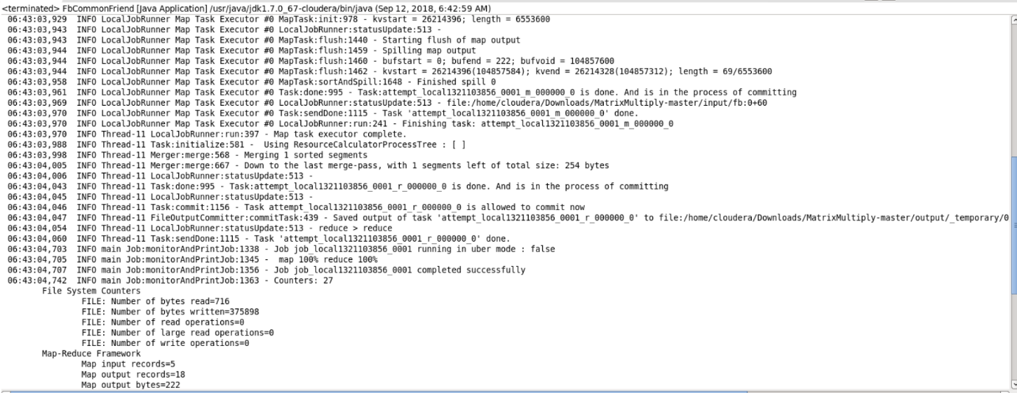

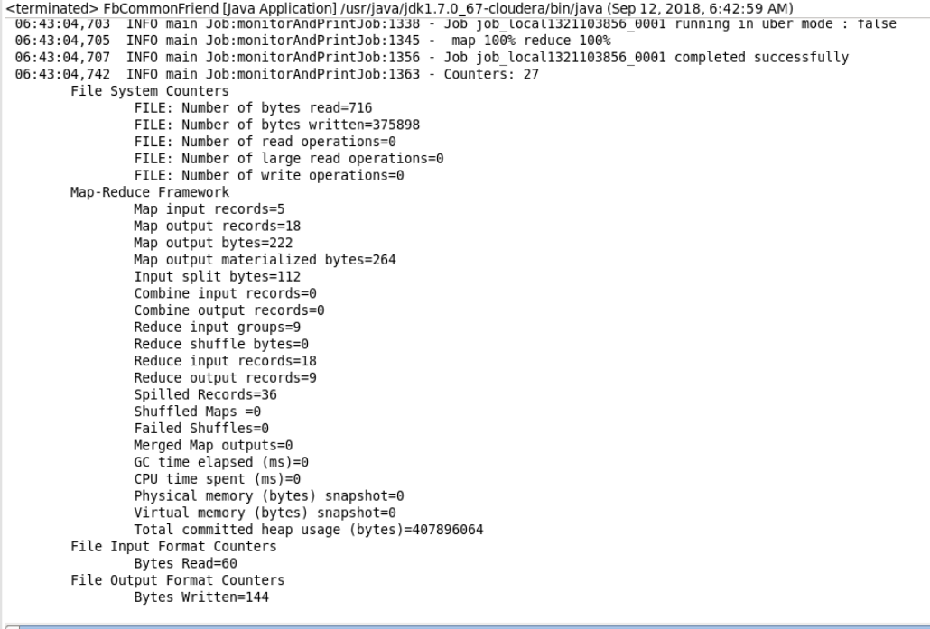

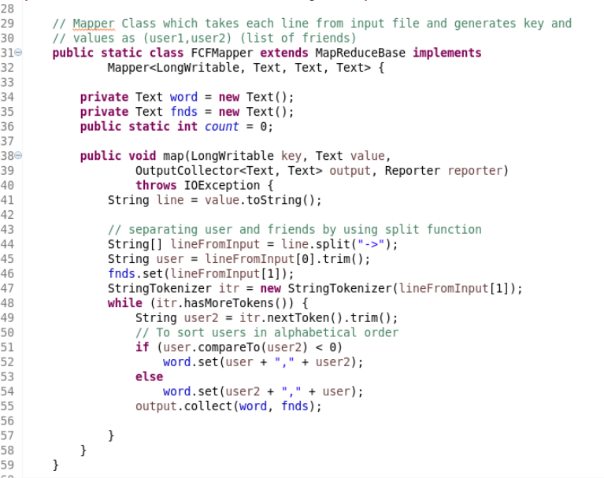

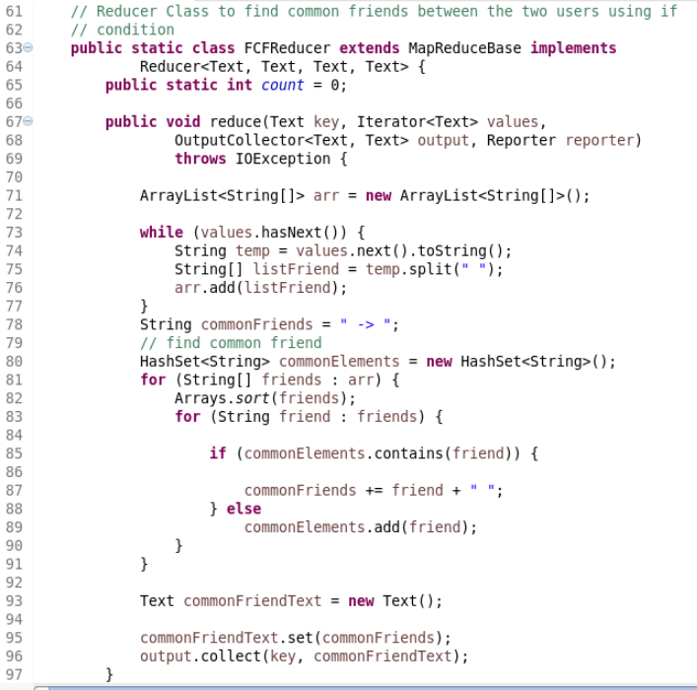

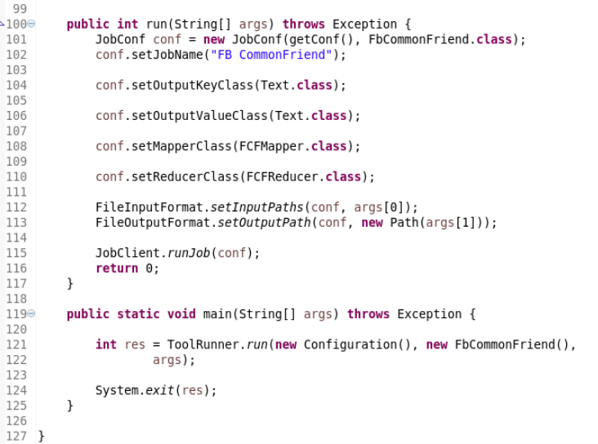

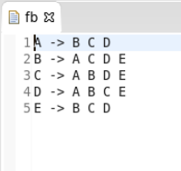

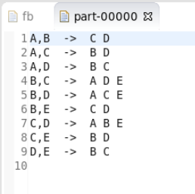





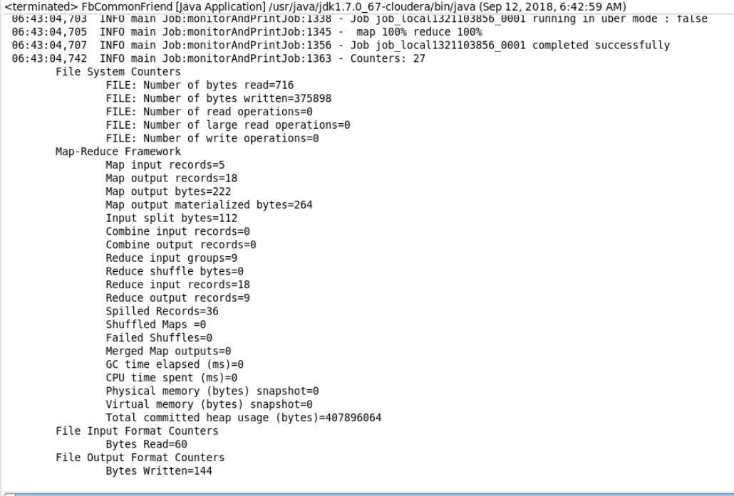

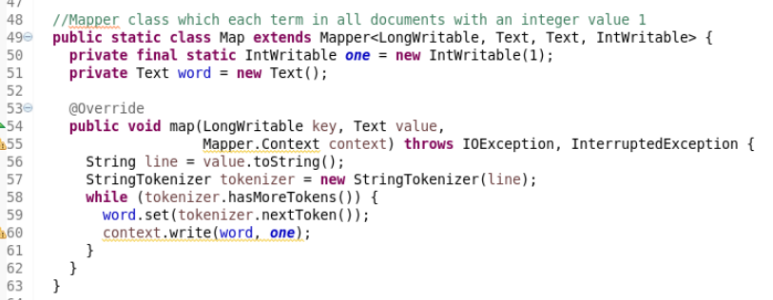

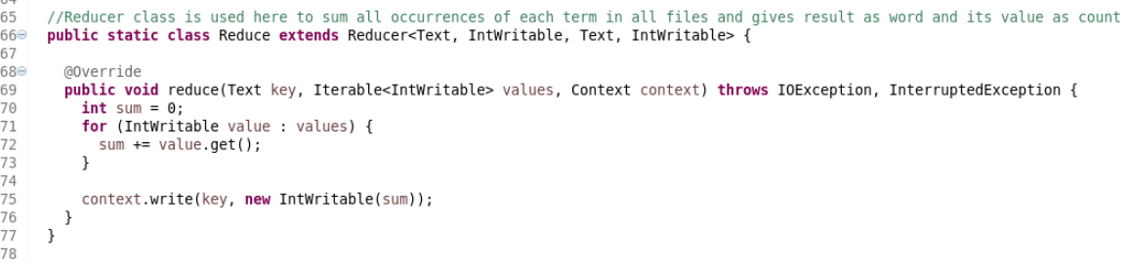

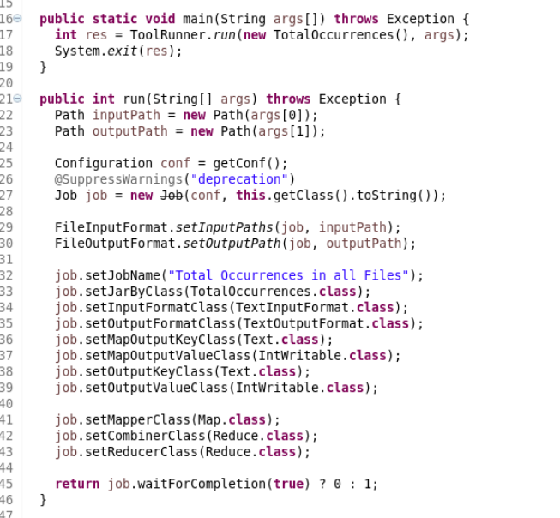

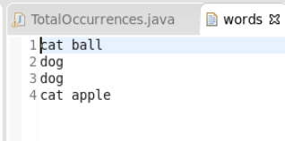

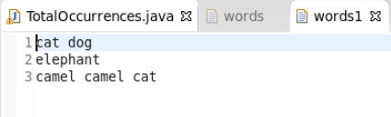

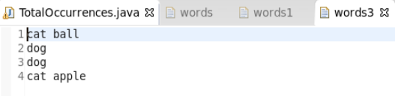

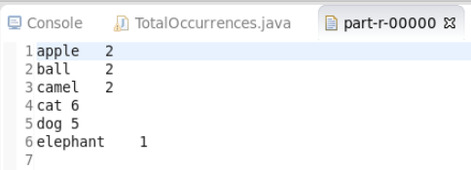

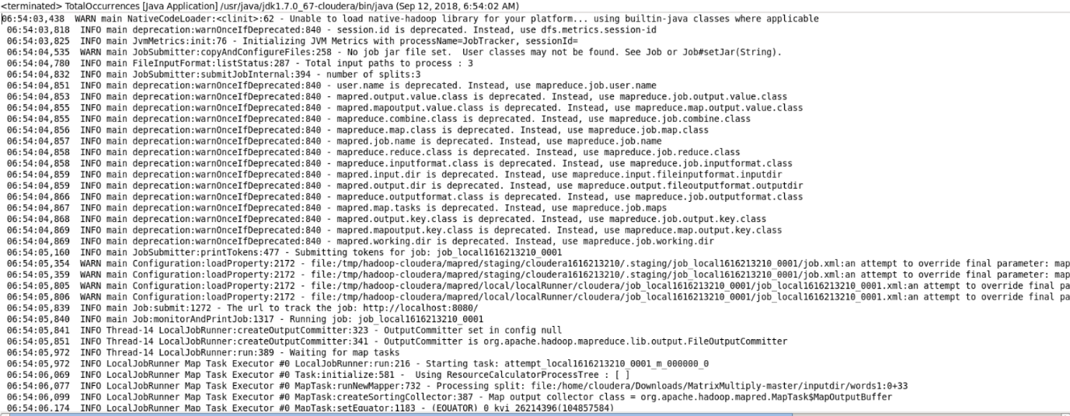

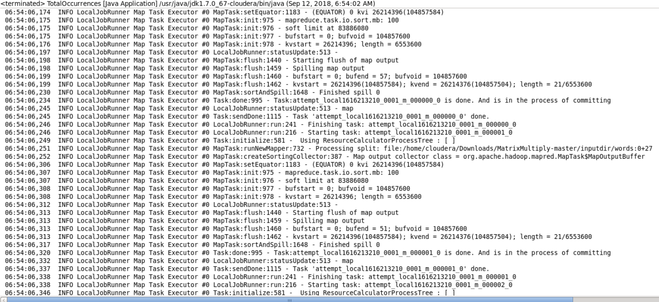

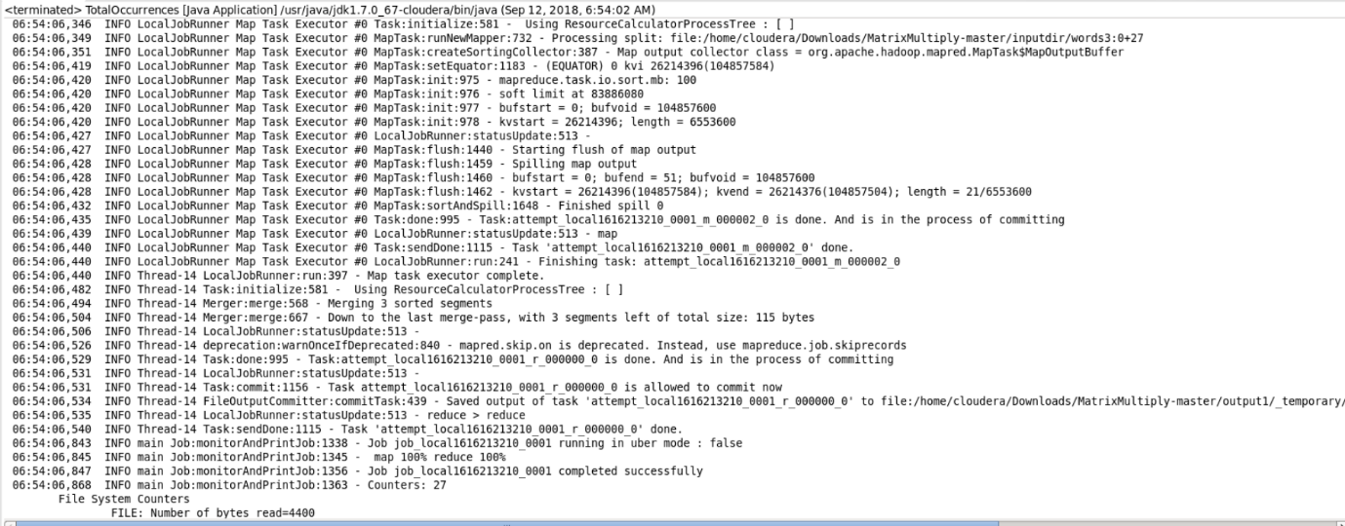

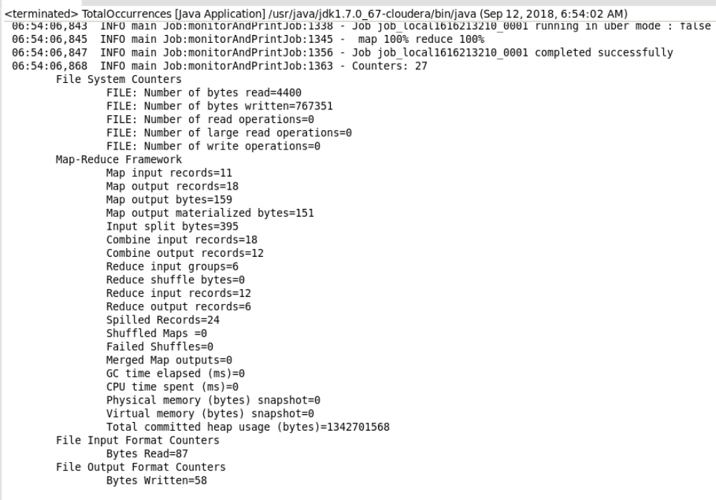

**Task 2**

**Objective :** To calculate total number of occurrences of each term in all documents, alternatively we can apply any arbitary function on the each term according to the requirement.

**Feautures :** This program can work on huge amounts of log data or any files and bring insights from them.

**Steps :**

**Input –**

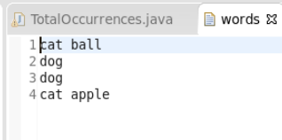

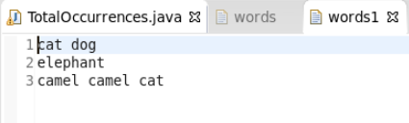

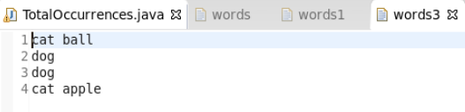

**Output –**

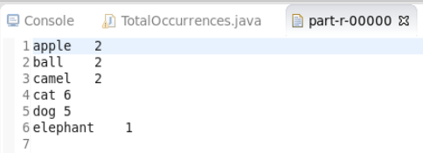

Here in input left side to arrow are the users and right side ones are his friends and are bidirectional that means if A is a friend of B then B is a friend of A. And in output file, we can see the mutual friends of any two users.

**Mapper :**

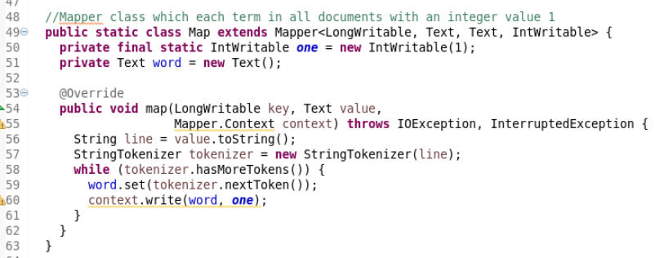

Here Map function gets input as byte offset as key and each line(cat ball) as value. StringTokenizer breaks each line into words splitting with space character. Each word in all documents is combined with an integer value one and sent to combiner and reducer as value with the key as word.

**Combiner :**

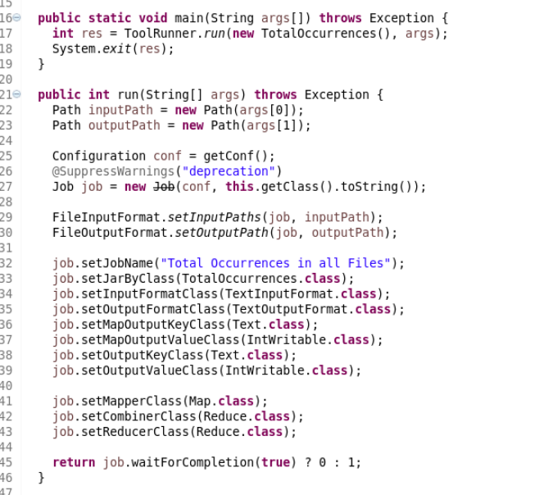

From above, we can see that the combiner class is same as the reducer class and it counts the total number of occurrences from each mapper to reduce effort on the reducer.

**Reducer :**

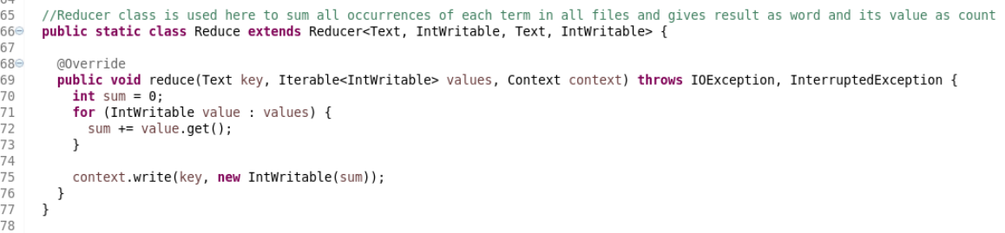

Each Reducer takes Similar key values from the mapper, and counts all the values of unique key and send it as output value. The result from the reducer is word and the number of its occurrences from all the documents.

In similar way, we can find an average of particular keys using combiner and reducer. This is mostly used in analysis of log files.

**Driver program :**



The driver program takes input and output folders as arguments and

Writes output to the file in output directory.

The log files generated while execution are



